**RDS Management uisng AWS API**

* Authenticate AWS credentials
* List the available instances
* Stop the running instances
* Start the instances after stopping

In order to do this task we need AWS secrets so that we can connect on to the aws account and do the specified actions from ruby script. Since our aws account has client instances I am providing you the code written which will work once the valid aws credentials have provided.

**Authenticate AWS credentials**

Authentication should be done by using a valid AWS Access Key and a AWS Secret Key.

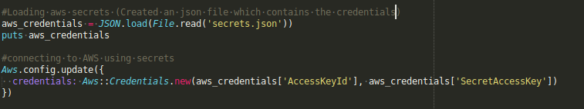

**List the available instances**

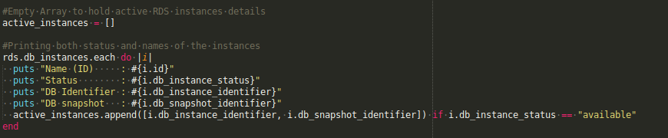

**Stop the running instances**

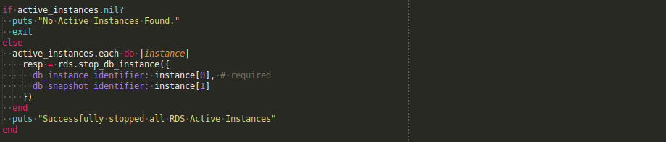

**Starting the stopped processes**

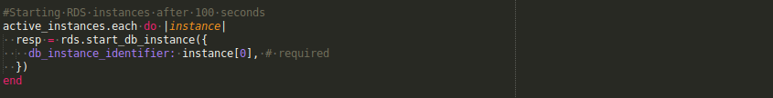

**Sample code Used**

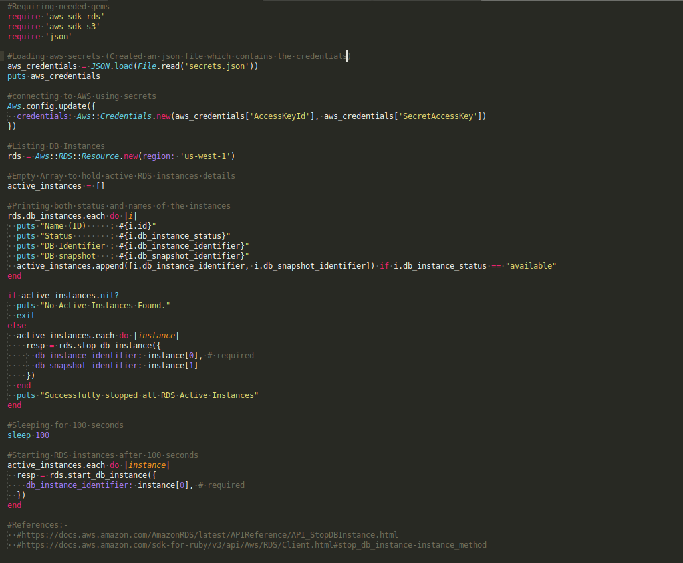

**Json file should be like this**

**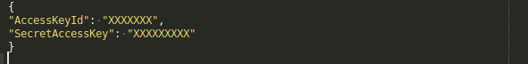**

References:-

1. <https://docs.aws.amazon.com/AmazonRDS/latest/APIReference/API_StopDBInstance.html>
2. **[https://docs.aws.amazon.com/sdk-for-ruby/v3/api/Aws/RDS/Client.html#stop\_db\_instance-instance\_method](https://docs.aws.amazon.com/sdk-for-ruby/v3/api/Aws/RDS/Client.html" \l "stop_db_instance-instance_method)**